Requirements Analysis   
Notifications for GCconnex

Table of Contents

1 Introduction 4

1.1 Scope, Purpose and Overview of the document 4

1.2 References 4

2 Functionality Proposition 5

2.1 Overview 5

2.2 Functional Requirements 6

2.2.1 Notifications 6

2.2.2 Site and Email Notifications 6

2.2.3 Digest or Newsletter Notifications 7

2.3 Non-Functional Requirements 8

2.3.1 Functional Performance and Maintenance 8

2.4 System Models 8

2.4.1 Use Cases, Scenarios and Mock ups 8

2.4.2 Use Cases and System Flow 20

3 Glossary 24

3.1 Administration Settings 24

Table of Figures

Figure 1 Unsubscribed content (see the bell icon) 6

Figure 2 Subscribed content (see the bell icon) 6

Figure 3 Inbox of in site notification messages 7

Figure 4 Gmail inbox with Notification Email messages 7

Figure 5 Notification content (new comment or reply) 8

Figure 6 Notification content (new content) 8

Figure 7 Idea not closed for discussion (see lock icon) 9

Figure 8 Idea closed for discussion (see lock icon) 9

Figure 9 Confirmation that the user wants to close the discussion 10

Figure 10 System acknowledges that the topic has closed 11

Figure 11 Minor Edit functionality 12

Figure 12 Functionality to allow user to choose whether to receive Digest 13

Figure 13 Notifications Digest options 13

Figure 14 Notifications Digest Workflow 17

Figure 15 Digest Settings Workflow 18

Figure 16 Notifications Workflow 19

Figure 17 Main notifications settings 21

Figure 18 Notifications subscription scripts 22

Figure 19 Troubleshooting subscription tool 22

Table of Tables

Table 1 Newly revised subject text 7

Table 2 Creating content subscription logic 19

Table 3 Commenting on content Subscription logic 20

Table 4 New content in group context subscription logic 20

Table 5 Editing content subscription logic 20

# Introduction

## Scope, Purpose and Overview of the document

The purpose of this document is to establish an agreement between the developer and the business analyst or clients regarding the functionality of the notification system. All new development work and modifications to existing functionality shall be included in this document to minimize scope creep and facilitate the consistency throughout all our development processes and to aid in developing tutorials for users. This document shall define and refine client requirements for specifically the notification functionality and will also list the changes and mock ups that will be implemented to further enhance notifications of GCconnex.

Due to time constraints, with discussions with the client, priorities for each change is defined as well as what is deemed out of scope for this release version. The lower priority items will be considered in future releases, so this will be release in stages or phases.

Testing scripts and test cases will be provided and accessible in this documentation.

The scope of this document will include all the enhancements and modifications that are agreed upon various discussions with the business group.

The Notifications for GCconnex shall be enhanced to allow a more customizable notification for users by allowing them to pick and choose (or subscribed to) what they want to receive either through site mail or email, or both. This functionality shall be based on external popular social media that includes but not limited to Facebook, Twitter and Wikipedia (or MediaWiki) and then incorporating to GCconnex (instance of an Elgg as the base of a collaboration platform).

Please be advised that the screenshots included in this document are for reference only and does not reflect the end state.

## References

There doesn’t seem to be any other documentation or materials for Notifications, however, there are some user generated blogs and discussions regarding the revamped notifications system.

Some of the materials in this document will help serve help materials for the Help desk team and to the GCconnex users.

# Functionality Proposition

## Overview

This is part of the initiative to revamp the whole notifications system on GCconnex to mimic the same functionality with other social medias such as Facebook and Twitter. It will allow users to better receive communications or information from other users and announcements from either their group or their colleagues.

## Functional Requirements

### Notifications

|  |  |  |  |
| --- | --- | --- | --- |
| FR # | Feature Name | Description | Priority |
| NFR-1 | Retiring Site Notifications & Site Messages | Users shall not have the ability to send site messages and receive site notifications. | High |
| NFR-2 | Administrative access | Site administrators shall be able to modify user notification account settings through the user’s notification settings page or through the administrative troubleshoot tool in the administrative panel without having to login as the user.  See section 3.1 Glossary (Administration settings) for more information. | Medium |
| NFR-3 | Notification Scripts | Site administrators shall be able to access and execute scripts that will automate the migration of old notifications to the new notification systems.  Site administrators shall be able to access and execute scripts that will automate in resolving inconsistent subscriptions or mismatching of subscriptions.  Site administrators shall be able to access and execute scripts that will automate in enabling the digest notification for all (with specific requirements) users. Specific requirement shall be available for selection.  GCconnex shall be able to migrate existing digest information to the new database structure upon plugin activation. | Medium |
|  |  |  |  |

### Site and Email Notifications

|  |  |  |  |
| --- | --- | --- | --- |
| FR # | Feature Name | Description | Priority |
| SEFR-1 | Subscription | Users shall be able to subscribe directly to contents. | High |
| SEFR-2 | Notification Subject Text | GCconnex shall send notifications containing the content name in the subject line when new action has taken place on content, either by creation or modification. The subject line shall contain both official languages; English and French. | High |
| SEFR-3 | Notification Body Text | GCconnex shall send notification containing more information within the email; content name, content link, user who has actioned the content, and links to helpdesk/feedback form and user account settings. The subject line shall contain both official languages; English and French. | High |
| SEFR-4 | Idea Finalization | Users shall be able to finalize an idea that they have created; to indicate a decision was made and provide description and notify users to close idea for discussion. The ideas functionality shall reside in a group context. | Medium |
| SEFR-5 | Minor Edit | Users shall be able to mark their changes as minor edit (similarly to GCpedia/MediaWiki) in which to prevent specific (activity) notifications from being sent. | Medium |
| SEFR-6 | Digest Option | Users shall be able to enable or disable a digest option under their account notification settings. Digest options shall include a packaged number of activities that the users customized for themselves.  See Section 3.2.2 for more information. | Low |
| SEFR-7 | Site or Email Notifications | Users shall be able to choose between Site or Email Notification (or both) for all activities except for user invitation, site registrations and site messages.  See Section NFR-1 for information regarding the Site notification changes. | Medium |
|  |  |  |  |

### Digest or Newsletter Notifications

|  |  |  |  |
| --- | --- | --- | --- |
| FR # | Feature Name | Description | Priority |
| DFR-1 | Digest Notification option | Users shall be able to opt-in or opt-out for the Digest Notification. GCconnex shall stop sending individual notifications and instead send a digest of all notifications in one email. | High |
| DFR-2 | Option for daily or weekly | Users shall be able to choose to either receive the digest notifications on a daily basis (around midnight EST) or on a weekly basis (midnight EST on Friday). | High |
| DFR-3 | Hot Items | GCconnex shall assemble all popular contents within a single email.  This functionality is still under discussion. | Low |
| DFR-4 | Notification Template | GCconnex shall assemble all the different activities within a single email that will contain (if applicable) content type, content title or name, content link, user action, user information, link to helpdesk/feedback form, and user settings. | High |
| DFR-5 | Digest Statistics | Site administrator shall be able to pull and extract information regarding users who have currently enabled the digest functionality. | Low |
|  |  |  |  |

## Non-Functional Requirements

### Functional Performance and Maintenance

|  |  |  |  |
| --- | --- | --- | --- |
| FR # | Feature Name | Description | Priority |
| FPNFR-1 | Notification efficiency | GCconnex shall be able to handle multiple requests via subscription and notification creation without requiring a lot of web application or database resources (memory). | High |
| FPNFR-2 | Notification reliability | GCconnex shall send all activities that have taken place (correctly) and to be received by the user (respective department must allow emails originated from GCconnex or TBS-GCconnex) | High |
| FPNFR-3 | Database integrity | GCconnex shall validate record integrity within the Database to minimize inaccurate subscriptions. | High |
|  |  |  |  |

## System Models

### Use Cases, Scenarios and Mock ups

#### Site and Email Notifications

**SEFR-1 Subscription**

Users will be able to unsubscribe or subscribe (in related terms, unfollow or follow) on individual groups, discussions, ideas, blogs, pages, calendar events, etc.

By default, users will be subscribed once they create a content or joined a group (will only subscribe to the group, not the group contents).

notifications for users to receive notifications for comments on pages, ideas and calendar events.

User’s subscription will be set to *receive/follow* by default and similar to Facebook, it will be the user to choose if he/she wishes to continue to follow/receive notifications. In addition, a link to unsubscribe to the notification of the item will be added to the email notification received by the user.

Also, should consider the option of being able to “Follow” certain things such as “Pages and Calendar”, as only the user who originally posted the content gets notifications.

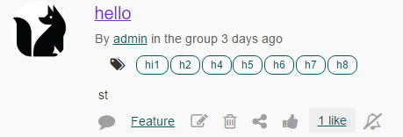

Figure 1 Unsubscribed content (see the bell icon)

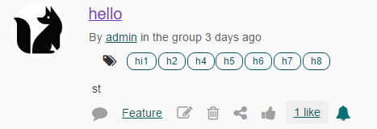

Figure 2 Subscribed content (see the bell icon)

However, users would not have the ability to subscribe to content that belongs to a group that they are not a member of. *Assuming that the user does not have write or edit access to a content that is within the group context that they are not a member of*.

**SEFR-2 Name of item in the email subject line**

When new contents (discussion, idea, etc.) are created, the item name should appear in the notification email subject line in order for the user to quickly identify for what the notification is for. This will allow users to quickly organize or filter their outlook inbox, by name and quickly identify which notifications they want to read.

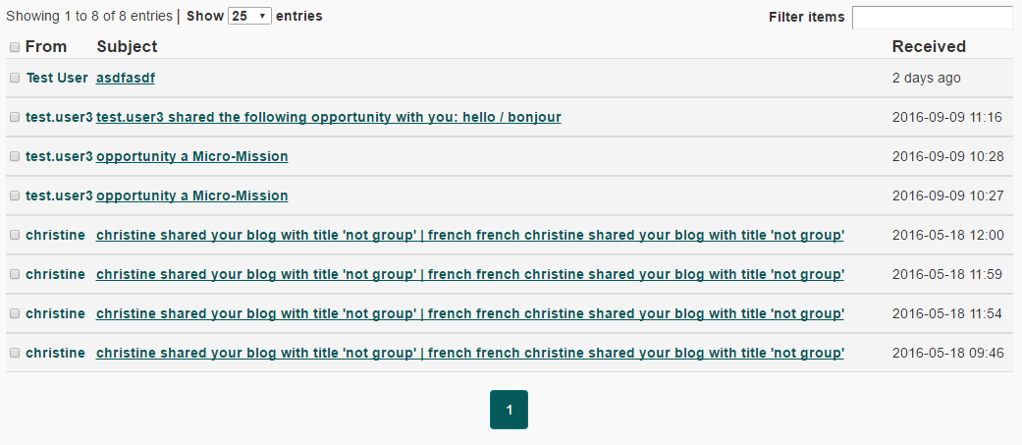

Figure 3 Inbox of in site notification messages

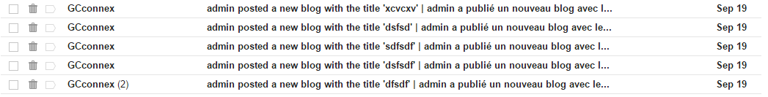

Figure 4 Gmail inbox with Notification Email messages

|  |
| --- |
| New reply to the discussion <item name> | Nouvelle réponse à la discussion <item name>  New comment on the blog <item name> | Nouveau commentaire sur le blogue <item name>  New comment on the page <item name> | Nouveau commentaire sur la page <item name>  New comment on the bookmark <item name> | Nouveau commentaire sur le signet <item name>  New comment on the file <item name> | Nouveau commentaire sur le fichier <item name> |

Table 1 Newly revised subject text

**SEFR-3 Notification email content**

Content and layout of the notification emails are confusing. A UX review will be conducted by Outreach and communications.

The content of the notification will contain some content and a link to the content so Users needn’t to be on the site to see the actual content itself. More accessible because the user wouldn’t need to log in (if they are not logged in and content is set to private).

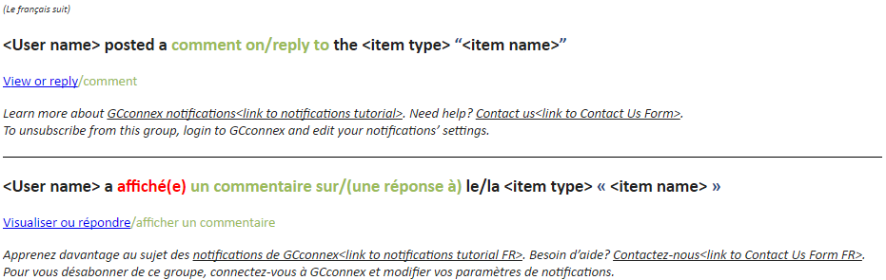

Figure 5 Notification content (new comment or reply)

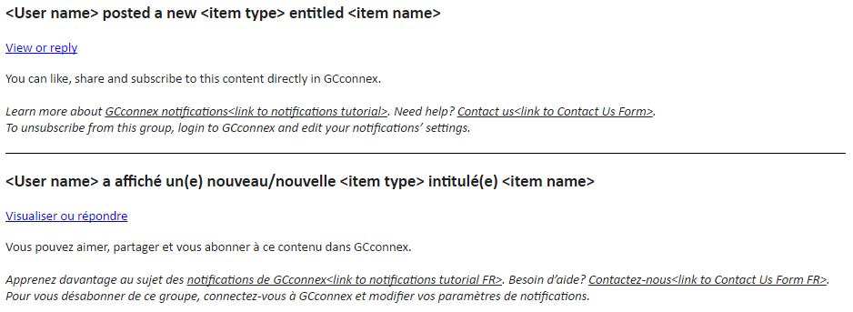

Figure 6 Notification content (new content)

**SEFR-4 Idea finalization**

Ability for the initiator of an idea to finalize/indicate that a decision was made, add decision description, and send notification to group and close the idea

Since this functionality can be implemented for other contents such as discussions, and Ideas have been removed, it will be implemented for discussions topic within groups for this scope.

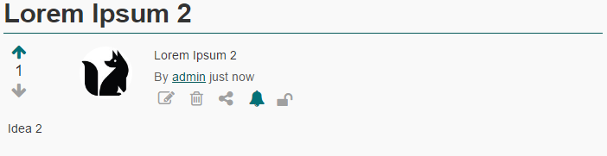

Figure 7 Idea not closed for discussion (see lock icon)

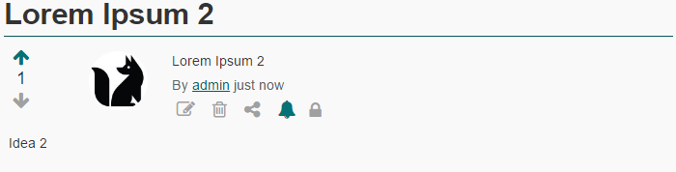

Figure 8 Idea closed for discussion (see lock icon)

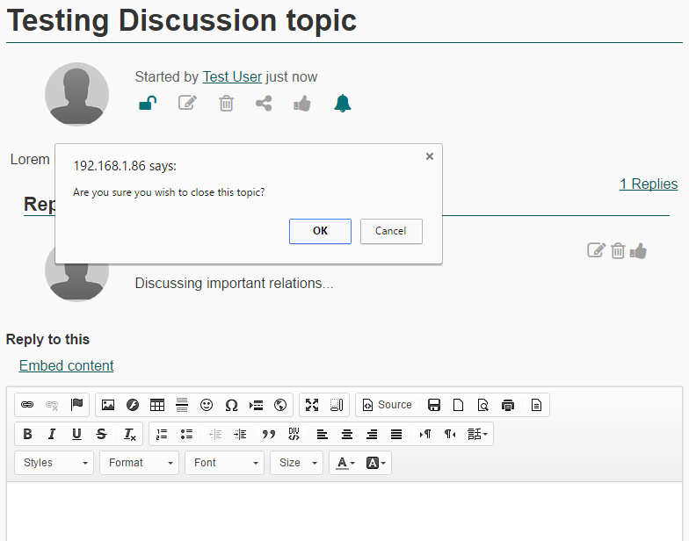

Figure 9 Confirmation that the user wants to close the discussion

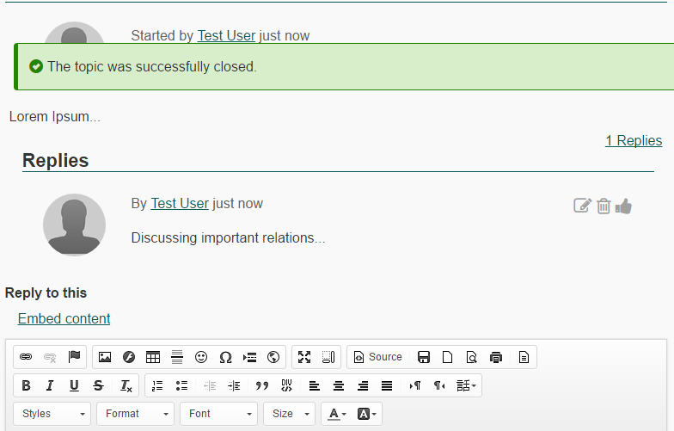

Figure 10 System acknowledges that the topic has closed

When a discussion topic is “locked”, no new comments or discussions will take place within that topic context. Users will know when a topic is “locked” by the little lock icon in the content menu.

**SEFR-5 Minor edit**

Add the ability for the user to mark their group changes as minor edits and prevent notifications from being sent.

The check box only needs to appear in the Edit page of content that would send a notification (ex: discussion, blog, page, etc.), as opposed to the group options – changing the description of the group does not send notifications.

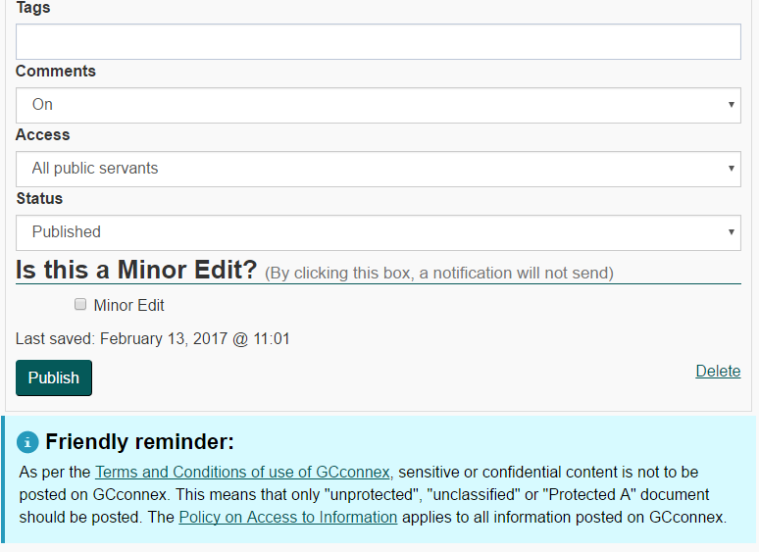

Figure 11 Minor Edit functionality

Since notifications are being invoked by modifying other content, this will be implemented further for other modules on GCconnex.

**SEFR-6 Digest option**

Add the ability for users to indicate that they want to receive their notifications in a digest (Bulk) format. GCconnex will keep the existing revamped notifications system and give the option to the user if they want the digest or not.

If they select “Enable Digest Feature”, the user will be presented with more options, customizing their digest. Albeit, only limited customization for now, due to time constraints. Will continue to improve Notifications system further in the future.

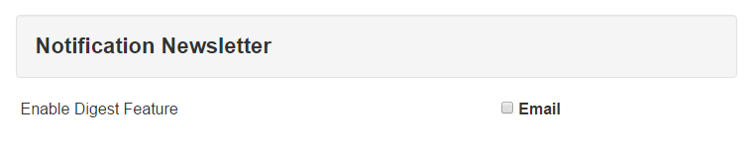

Figure 12 Functionality to allow user to choose whether to receive Digest

#### Digest or Newsletter Notifications

**DFR-1 Digest Notification option**

To find information with regards to how to get more options for the Digest, *See SEFR-6* (section above).

Once the user has decided to enable the Digest Feature, GCconnex will present them with additional limited options.

|  |  |
| --- | --- |
| Receiving frequency for Digest | Preferred language for the Digest |
| Daily:  Users will receive the digest every day (around 4:00AM or 5:00AM EST) | **English**:  Digest will be sent out to user in English |
| Weekly:  Users will receive the digest every week (Friday or Saturday around 4:00AM or 5:00AM EST) | **French**:  Digest will be sent out to user in French |

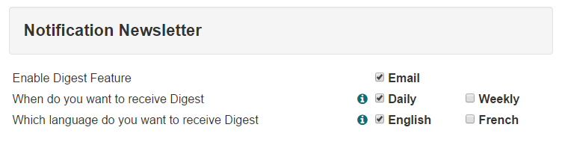

Figure 13 Notifications Digest options

|  |  |
| --- | --- |
| What is included in the Notifications Digest | What is not included in the Notifications Digest |
| New Bookmark | Add group moderator |
| New Blog | Group admin transfer |
| New File | Colleague request approval |
| New Event | Adding users to the group |
| New Images | Send message to User within Group |
| New Opportunities | Send message to User |
| New Poll | Password Request |
| New Wire post | Registration |
| New Group Discussions | Add new user to GCconnex |
| New Pages |  |
| New Ideas | New Skills |
| New Forum | Profile About me |
| New Forum Topic | New Education |
| New Forum Topic post | New Work Experience |
|  | Second Language Evaluation |
| New Likes | New Widget |
| New comments | New Portfolio items |
| New Wire share | GEDs Sync |
| New Content share | Feedback/Contact Us form |
|  | New Avatar |
| Modify Blog | New Group Cover image |
| Modify Discussion Topic | Lock Discussion Topic |
| Modify Pages |  |
|  |  |
| New Colleague request |  |
|  |  |

**DFR-2 Option for daily or weekly**

Allow users to select how frequent the digest notifications will be sent out (available option would be daily or weekly basis). For more explanation, see section *DFR-1* for the information table.

**DFR-3 Hot Items**

This will be either separate email notification or contained in all emails that will list out all the contents that are popular among the users (calculated through the number of likes, and comments).

*To be further discussed.*

**DFR-4 Notification Template**

The digest will contain a more compacted information for the users, to reduce the feeling of overwhelming. This is an initiative to reduce the amount of emails fired out to user’s Outlook inbox.

This will also display only in French or English depending on what the user has set from their Notifications Settings page. The reason being, that this will help with readability and limit real estate (so users needn’t scroll so much).

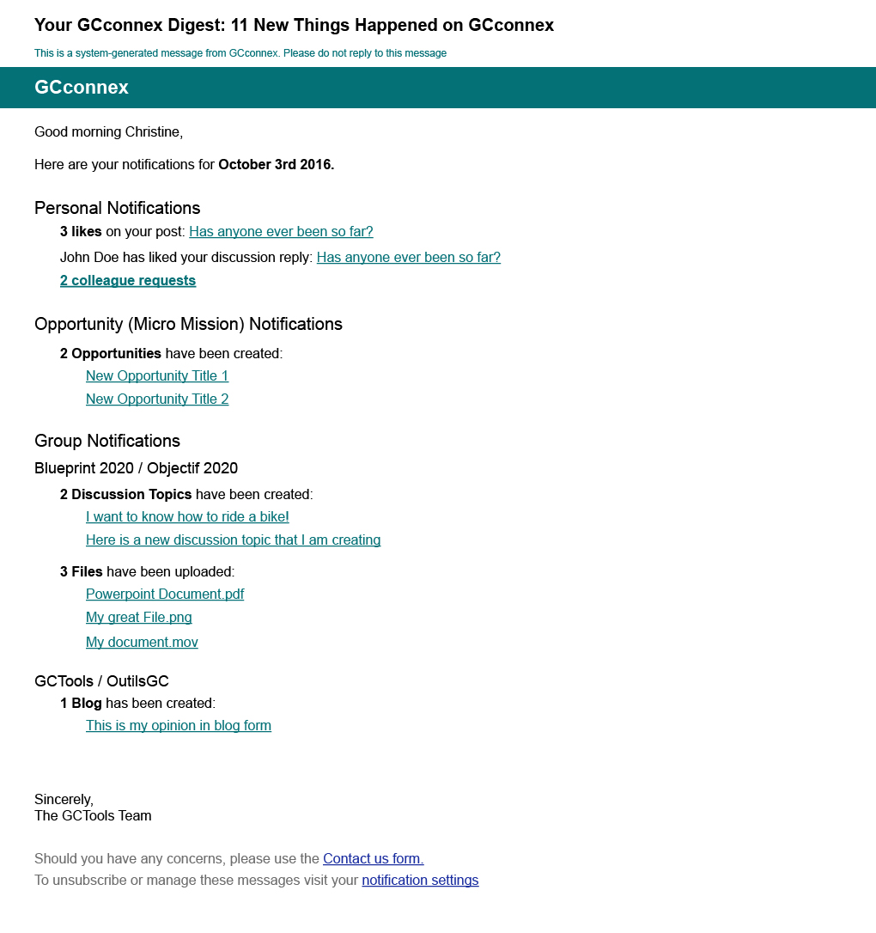

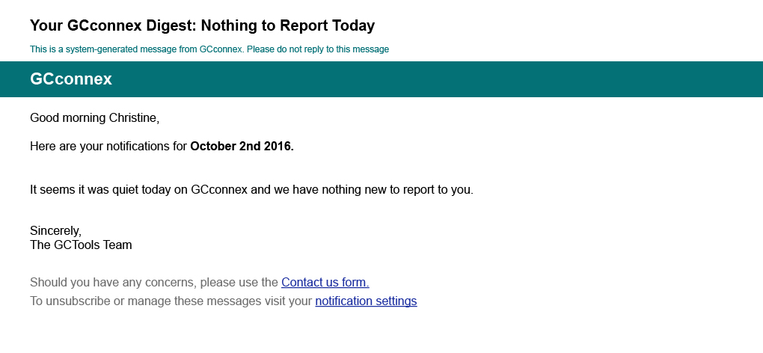

### Use Cases and System Flow

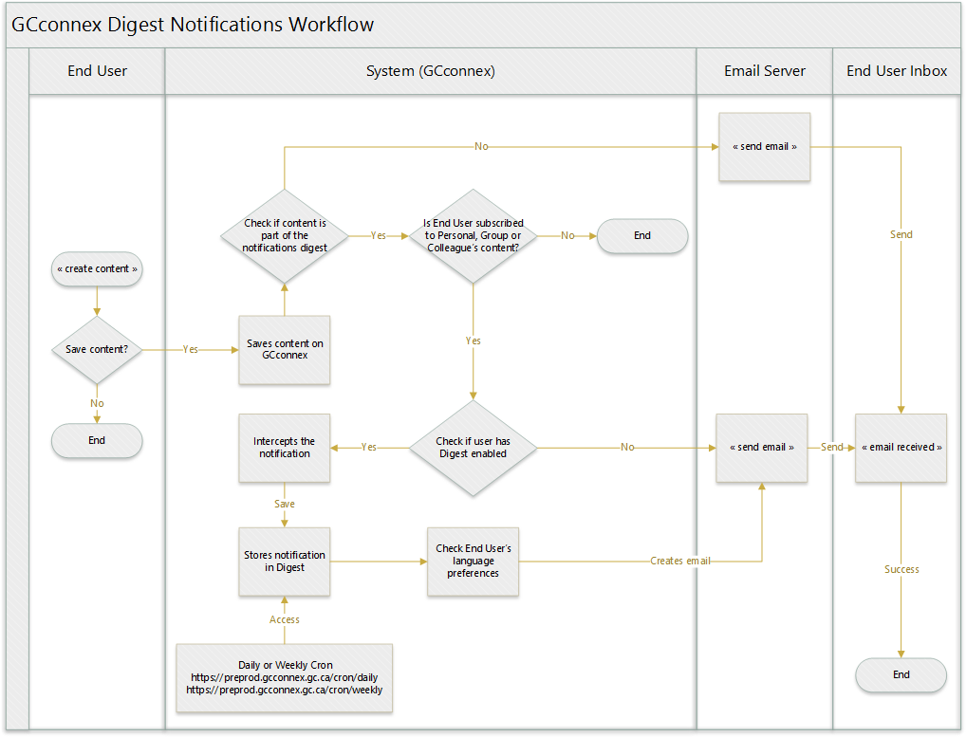

Figure 14 Notifications Digest Workflow

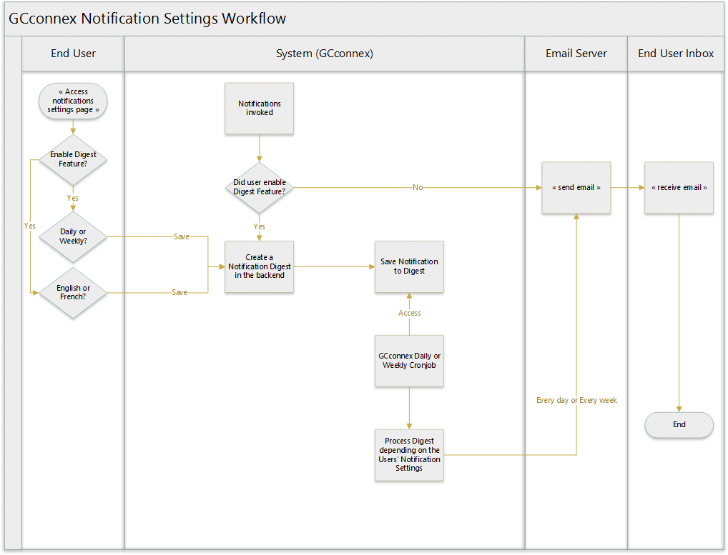

Figure 15 Digest Settings Workflow

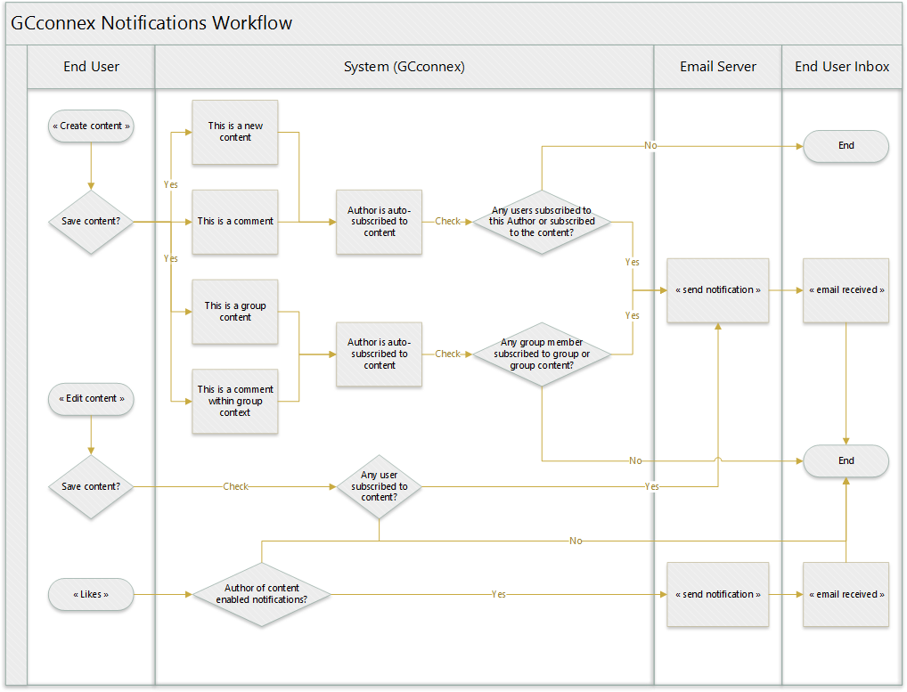

Figure 16 Notifications Workflow

Table 2 Creating content subscription logic

|  |  |  |
| --- | --- | --- |
| Content | Subscribe on creation | Option for e-mail and site mail |
| Group | Not subscribed (link in profile not functional) | YES |
| Discussion Topic | Subscribed | NO |
| File | Subscribed | NO |
| Blog | Subscribed | NO |
| Pages | Subscribed | NO |
| Bookmark | Subscribed | NO |
| Ideas | Subscribed | NO |
| Polls | Subscribed | NO |
| Album | Subscribed | NO |
| Photos | Not subscribed (no indication, or option) | NO |
| Wire post | Subscribed | NO |
| Forum Topic | Not subscribed | NO |

Table 3 Commenting on content Subscription logic

|  |  |
| --- | --- |
| Group | No auto-subscription |
| Discussion Topic | No auto-subscription |
| File | No auto-subscription |
| Blog | No auto-subscription |
| Pages | No auto-subscription |
| Bookmark | No auto-subscription |
| Ideas | No auto-subscription |
| Polls | No auto-subscription |
| Album | No auto-subscription |
| Photos | No auto-subscription |
| Wire post | No auto-subscription |
| Forum Topic | No auto-subscription |

Table 4 New content in group context subscription logic

|  |  |  |
| --- | --- | --- |
| Content | Notification Status to Group Member | Subscription Status |
| Discussion Topic | Yes e-mail / No site-mail | No auto-subscription |
| File | Yes e-mail / No site-mail | No auto-subscription |
| Blog | Yes e-mail / No site-mail | No auto-subscription |
| Pages | Yes e-mail / No site-mail | No auto-subscription |
| Bookmark | Yes e-mail / No site-mail | No auto-subscription |
| Ideas | Yes e-mail / No site-mail | No auto-subscription |
| Polls | Yes e-mail / No site-mail | No auto-subscription |
| Album | Yes e-mail / No site-mail | No auto-subscription |
| Photos | Yes e-mail / No site-mail | No auto-subscription |
| Forum Topic | Yes e-mail / Yes site-mail | No auto-subscription |

Table 5 Editing content subscription logic

|  |  |
| --- | --- |
| Discussion Topic | No notification sent |
| File | No notification sent |
| Blog | No notification sent |
| Pages | No notification sent |
| Bookmark | No notification sent |
| Ideas | No notification sent |
| Polls | No notification sent |
| Album | No notification sent |
| Photos | No notification sent |
| Forum Topic | No notification sent |

# Glossary

## Administration Settings

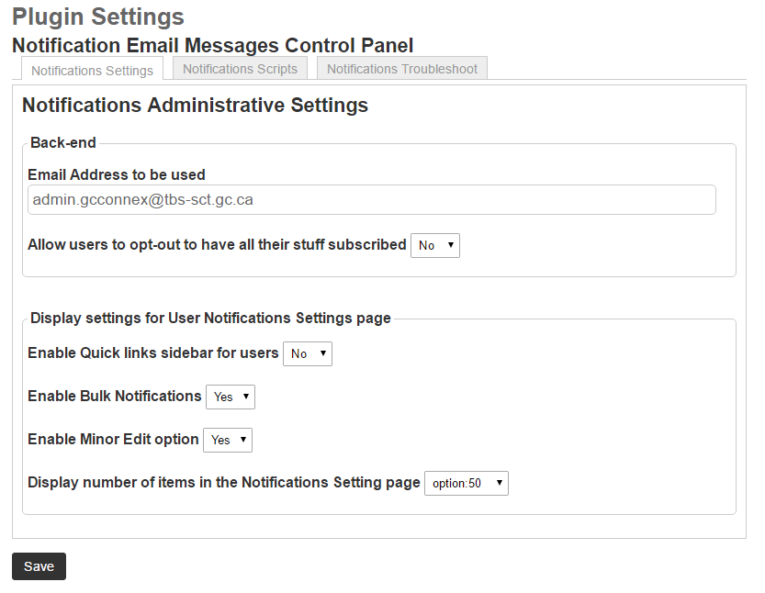

Figure 17 Main notifications settings

The Administrative Settings pages have been cleaned up and revamped to make it more readable and useable for Helpdesk purposes.

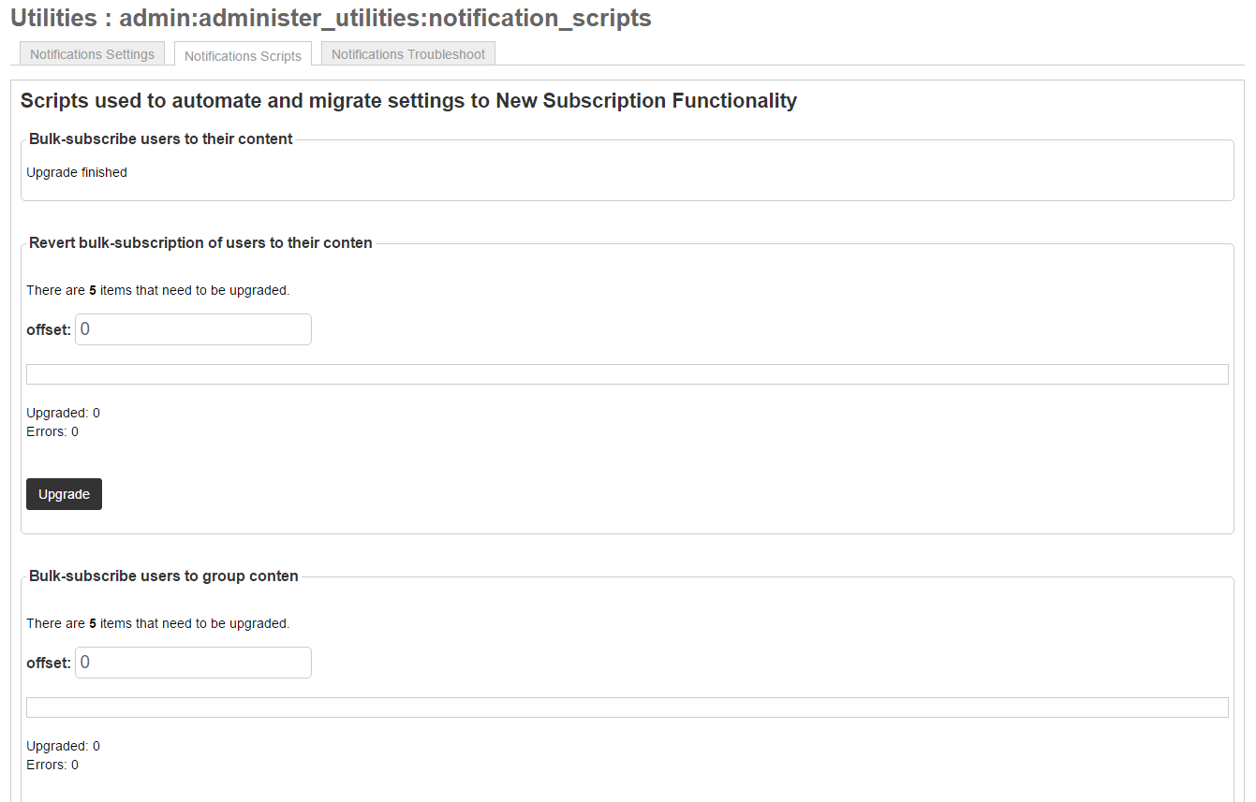

Figure 18 Notifications subscription scripts

The Notification scripts only affect the back end, database changes. This should only be used by developers.

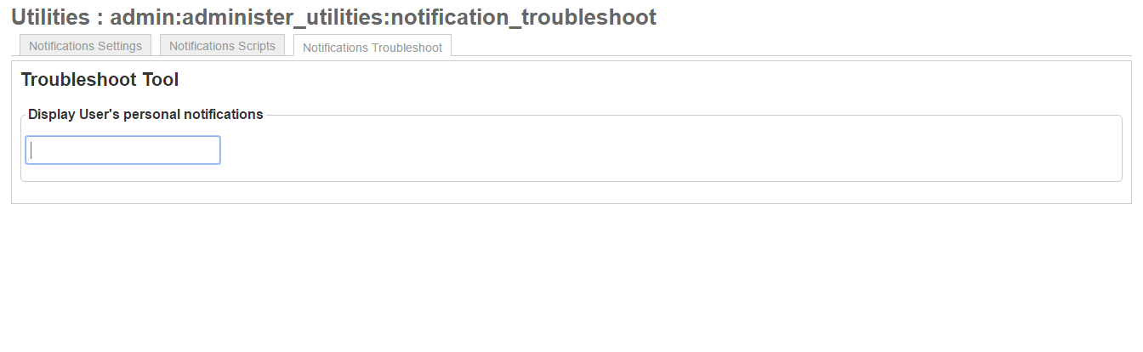

Figure 19 Troubleshooting subscription tool

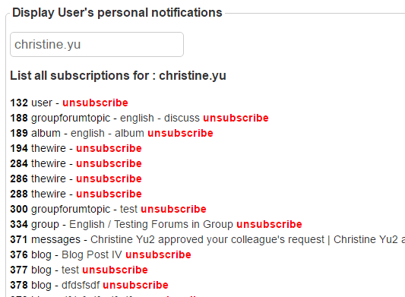

Figure 20 Listing of all the subscriptions for a user

There will be a new tool for Helpdesk to troubleshoot and fix up individual Subscription/Notification settings. The initiative to help improve the new Notifications system for GCconnex.